**How to Import SQL File into Database**

1. Open MySQL Workbench
2. Enter My SQL Connection, If you have empty, create new one.

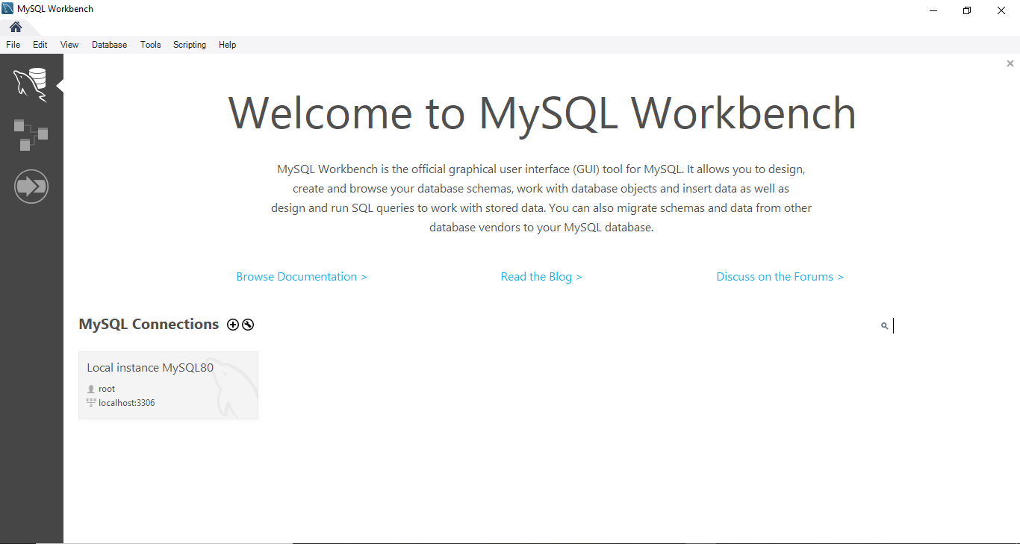

1. Create Database for New Import Data

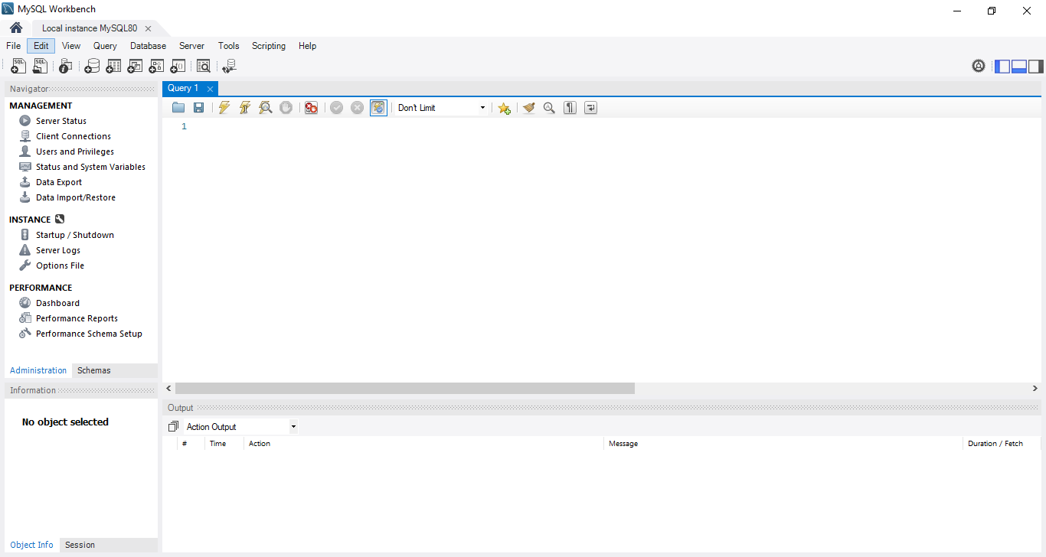

1. Write Database Name

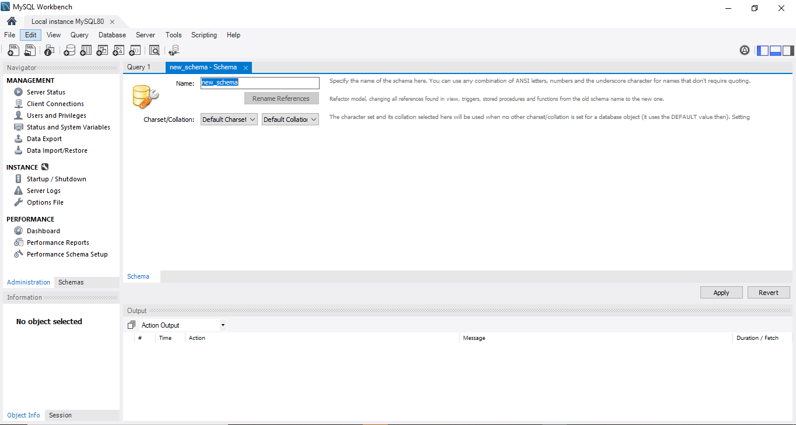

1. Select Administration in Navigator Tab



1. Select Data Import/Restore



1. Check 「Import from Self-Contained File」and Select Your SQL File

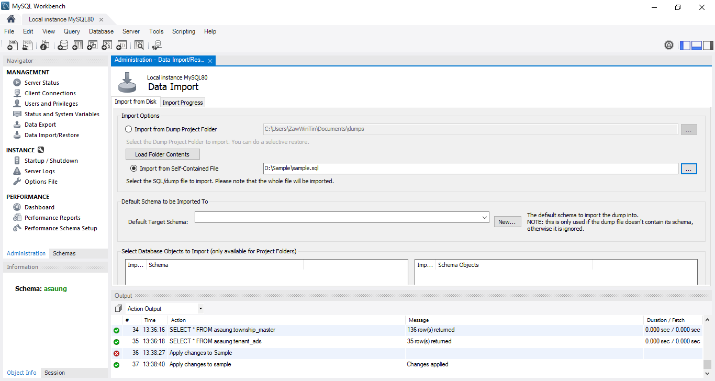

1. Select Database that will be imported

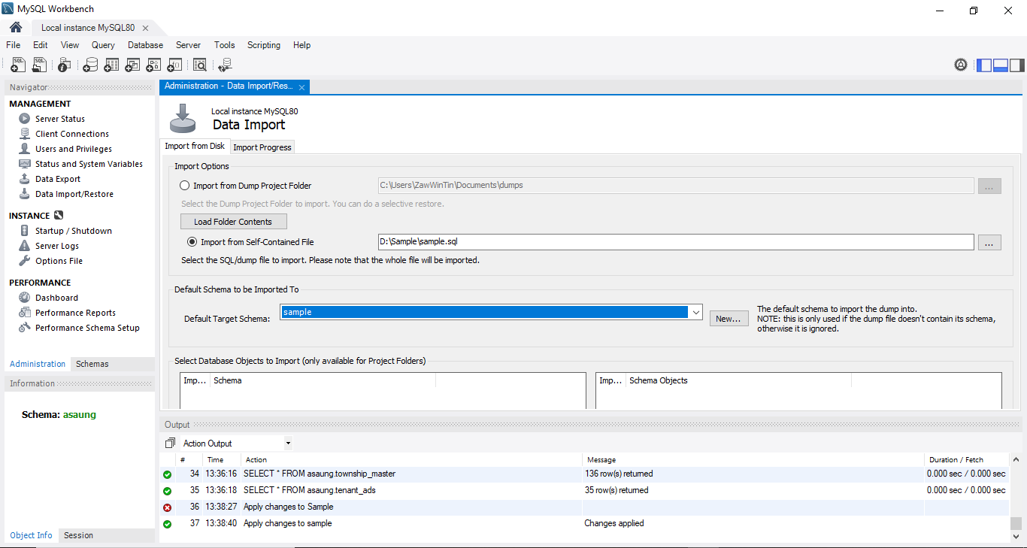

1. Select Import Progress Tab and Click 「Start Import」

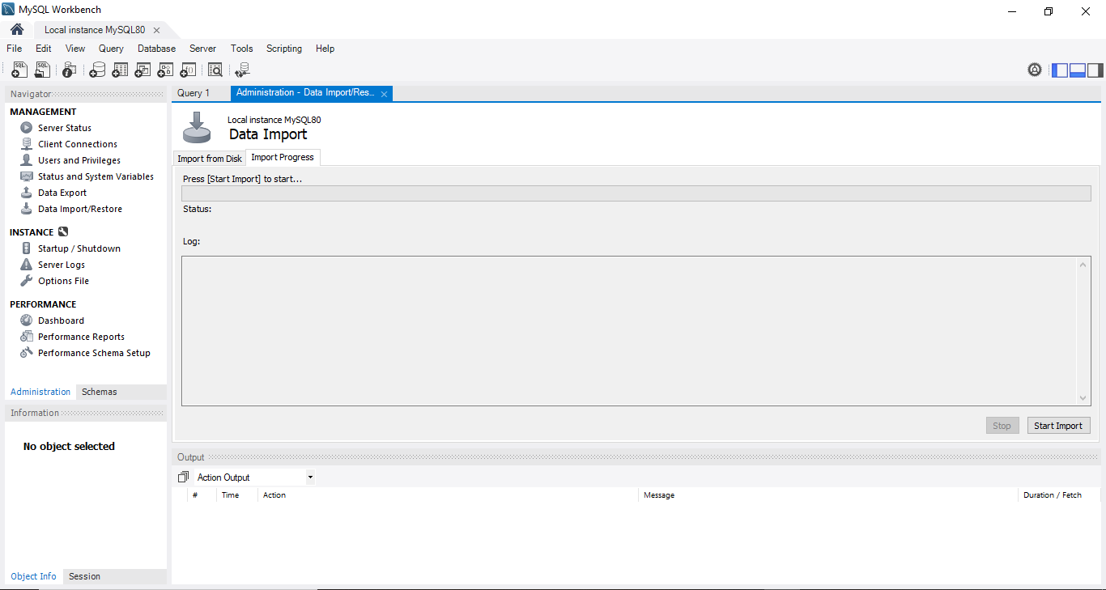

*That will import SQL file to Your Database. . .*